# IOT Prject V2.

# Composents

|  |  |  |
| --- | --- | --- |
| Thermomètre | 0.90€ | https://fr.aliexpress.com/item/New-Waterproof-Digital-Thermal-Probe-or-Sensor-DS18B20-Length-1M/2036891617.html?spm=a2g0w.search0104.3.2.4b08556a9x2oBm&ws_ab_test=searchweb0_0,searchweb201602_1_10152_10065_10151_10344_10068_10342_10343_10340_5722611_10341_10698_10697_10696_5722911_5722811_10084_5722711_10083_10618_10305_10304_10307_10306_10302_10059_10184_10534_308_100031_10103_441_10624_10623_10622_10621_10620_5723011_5722511,searchweb201603_2,ppcSwitch_2&algo_expid=241172be-a0db-4e53-9f08-ff106c9dc3dc-0&algo_pvid=241172be-a0db-4e53-9f08-ff106c9dc3dc&transAbTest=ae803_2&priceBeautifyAB=0 |
| Arduino nano | 2.06€ | https://fr.aliexpress.com/item/MINI-USB-NANO-V3-0-CH340-CH340G-5-V-16-M-Atmega328-ATmega328P-Micro-Carte-Contr/32844325460.html?spm=a2g0w.search0104.3.8.25005d4cfbh9Cp&ws_ab_test=searchweb0_0%2Csearchweb201602_1_10152_10065_10151_10344_10068_10342_10343_10340_5722611_10341_10698_10697_10696_5722911_5722811_10084_5722711_10083_10618_10305_10304_10307_10306_10302_10059_10184_10534_308_100031_10103_441_10624_10623_10622_10621_10620_5723011_5722511%2Csearchweb201603_2%2CppcSwitch_2&algo_expid=28eb2cf5-6b89-45ee-b0fe-056db1aad93b-1&algo_pvid=28eb2cf5-6b89-45ee-b0fe-056db1aad93b&transAbTest=ae803_2&priceBeautifyAB=0 |
| Alimentation Arduino nano | 0.08€ | https://fr.aliexpress.com/item/100pcs-lot-9-V-Battery-Connector-9V-snap-Clip-Lead-Wire-PVC-Soft-Leather-Battery-Holder/32825889060.html?spm=a2g0w.search0104.3.9.28647040WSueVJ&ws_ab_test=searchweb0_0,searchweb201602_1_10152_10065_10151_10344_10068_10342_10343_10340_5722611_10341_10698_10697_10696_5722911_5722811_10084_5722711_10083_10618_10305_10304_10307_10306_10302_10059_10184_10534_308_100031_10103_441_10624_10623_10622_10621_10620_5723011_5722511,searchweb201603_2,ppcSwitch_2&algo_expid=b018d3d5-0b11-4573-ad2d-664941cfe0ad-1&algo_pvid=b018d3d5-0b11-4573-ad2d-664941cfe0ad&transAbTest=ae803_2&priceBeautifyAB=0 |
| Pile 9V | 8€ | https://fr.aliexpress.com/item/2PCS-Free-Shipping-9V-Li-ion-780mAh-Microphones-Battery-Pile-PP3-6LR61-6LR21-MN1604-6LF22/32276602839.html?spm=a2g0w.search0104.3.2.37207e90AbDVsB&ws_ab_test=searchweb0_0,searchweb201602_1_10152_10065_10151_10344_10068_10342_10343_10340_5722611_10341_10698_10697_10696_5722911_5722811_10084_5722711_10083_10618_10305_10304_10307_10306_10302_10059_10184_10534_308_100031_10103_441_10624_10623_10622_10621_10620_5723011_5722511,searchweb201603_2,ppcSwitch_2&algo_expid=4765cd7b-02e9-43a2-9683-8613c6ae7142-0&algo_pvid=4765cd7b-02e9-43a2-9683-8613c6ae7142&transAbTest=ae803_2&priceBeautifyAB=0 |
| Module radio RF433 | 0.52€ | https://fr.aliexpress.com/item/2PCS-433Mhz-RF-transmitter-and-receiver-kit-for-Arduino-ARM-MCU-WL/32292902669.html?spm=a2g0w.search0104.3.2.32aa3bf8mI9QWz&ws_ab_test=searchweb0_0,searchweb201602_1_10152_10065_10151_10344_10068_10342_10343_10340_5722611_10341_10698_10697_10696_5722911_5722811_10084_5722711_10083_10618_10305_10304_10307_10306_10302_10059_10184_10534_308_100031_10103_441_10624_10623_10622_10621_10620_5723011_5722511,searchweb201603_2,ppcSwitch_2&algo_expid=8dd1ed64-0dac-41cb-bed1-546875a97da0-0&algo_pvid=8dd1ed64-0dac-41cb-bed1-546875a97da0&transAbTest=ae803_2&priceBeautifyAB=0 |
| Orange PI | 13.00€ | https://fr.aliexpress.com/item/Orange-Pi-PC-linux-and-android-mini-PC-Beyond-Raspberry-Pi-2/32448079125.html?spm=a2g0w.search0104.3.169.6cd1797aJf9Pnm&ws_ab_test=searchweb0_0,searchweb201602_1_10152_10065_10151_10344_10068_10342_10343_10340_5722611_10341_10698_10697_10696_5722911_5722811_10084_5722711_10083_10618_10305_10304_10307_10306_10302_10059_10184_10534_308_100031_10103_441_10624_10623_10622_10621_10620_5723011_5722511,searchweb201603_2,ppcSwitch_2&algo_expid=60647b02-8a85-4188-a58b-43752b9991a1-27&algo_pvid=60647b02-8a85-4188-a58b-43752b9991a1&transAbTest=ae803_2&priceBeautifyAB=0 |
| Alimentation PI | 4.30€ | https://fr.aliexpress.com/item/5-V-2A-AC-DC-Power-Adapter-Mur-Chargeur-Pour-Samsung-Galaxy-Tab-3-7-0/32838776158.html?spm=a2g0w.search0104.3.2.519328213VaowG&ws_ab_test=searchweb0_0%2Csearchweb201602_1_10152_10065_10151_10344_10068_10342_10343_10340_5722611_10341_10698_10697_10696_5722911_5722811_10084_5722711_10083_10618_10305_10304_10307_10306_10302_10059_10184_10534_308_100031_10103_441_10624_10623_10622_10621_10620_5723011_5722511%2Csearchweb201603_2%2CppcSwitch_2&algo_expid=86264fba-76c7-4e00-8f7e-ca2895728dbf-0&algo_pvid=86264fba-76c7-4e00-8f7e-ca2895728dbf&transAbTest=ae803_2&priceBeautifyAB=0 |
| Carte SD PI | 7.70€ | https://fr.aliexpress.com/item/D-origine-SanDisk-Micro-SD-16-gb-32-gb-64-gb-128-gb-tarjeta-Carte-M/32850328253.html?spm=a2g0w.search0104.3.2.2eda406c1XpMgA&ws_ab_test=searchweb0_0%2Csearchweb201602_1_10152_10065_10151_10344_10068_10342_10343_10340_5722611_10341_10698_10697_10696_5722911_5722811_10084_5722711_10083_10618_10305_10304_10307_10306_10302_10059_10184_10534_308_100031_10103_441_10624_10623_10622_10621_10620_5723011_5722511%2Csearchweb201603_2%2CppcSwitch_2&algo_expid=0a9bb334-2630-4955-a95e-4d50bfd34fd5-0&algo_pvid=0a9bb334-2630-4955-a95e-4d50bfd34fd5&transAbTest=ae803_2&priceBeautifyAB=0 |
| Stockage cloud | 30€/mois | https://cloud.oracle.com/big-data/big-data/pricing |

# Plan

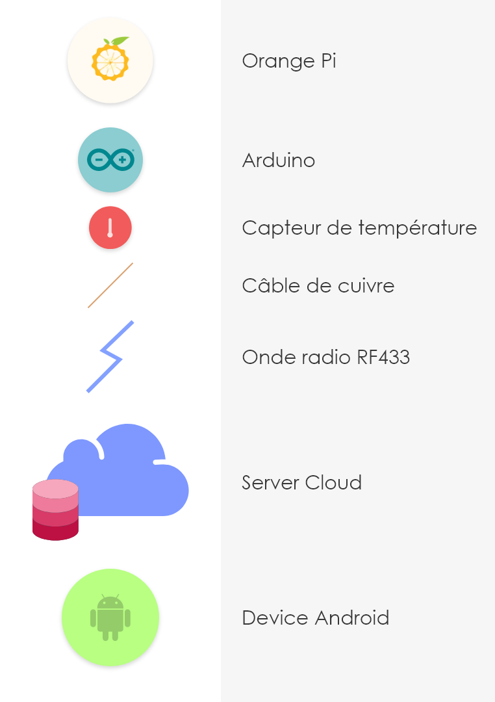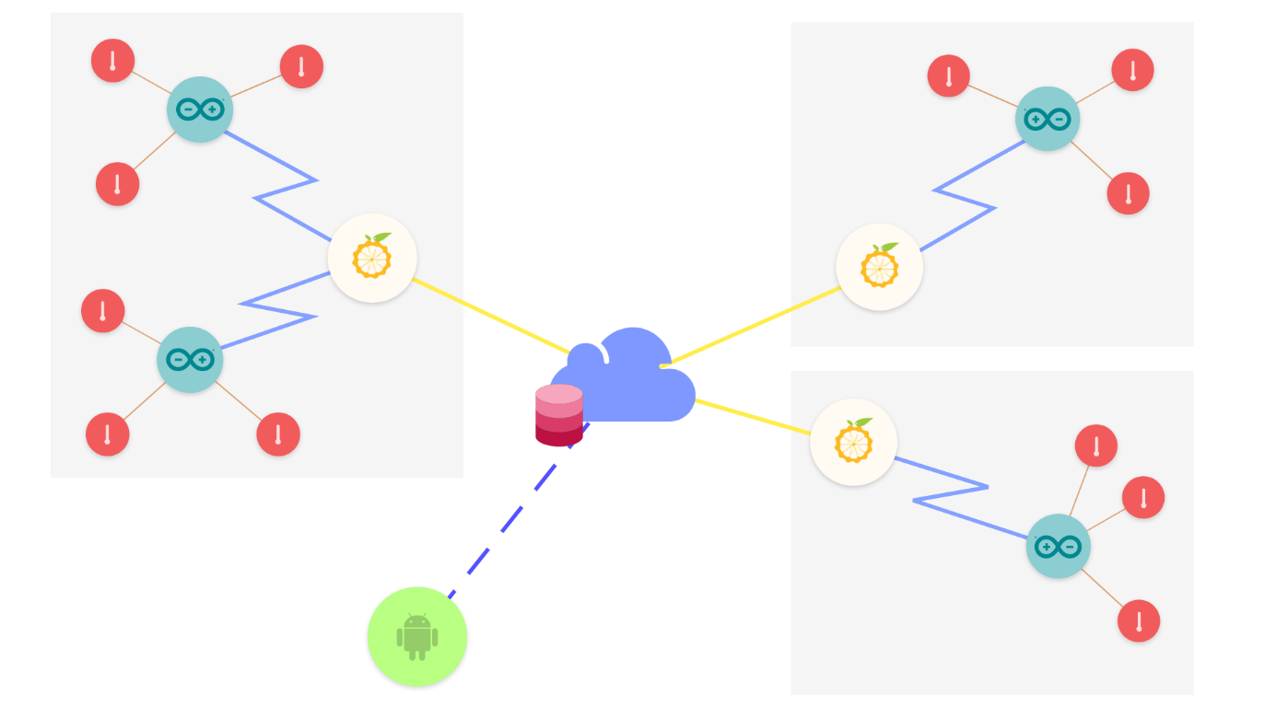

# Calcul de Cout

## Avec :

* 1 thermomètre par Arduino;
* 80 Arduino par site;
* Une orange PI par site;
* 10 site;

## Cela fait :

* 6*80 = 480 Thermomètre
* 20*10 = 480 Arduino Nano
* 10 Orange Pi

## Prix groupe

* Thermomètre : 0,90€
* Arduino : 2,06 + 0,08 + 8 + 0,52 = 10,66
* Orange PI : 13,00+4,30+7,70 = 25,00

## Prix total :

480*0.90 + 480*10.66 + 25.00*10 = 5583,80€

* Prix Unité thermomètre : 5583,80 / 480 = 11,6€
* Prix Unité Site : 558,38€

# Calcule des données

Données envoyées tous les 30s depuis un thermomètre ;

Il y a 480 Thermomètre

## Calcule format brut

Taille : 18 octet

2 octet : ID du thermomètre

4 octet : température

4 octet : timestamp

8 octet : ID enregistrement

18 * 2 * 480 * 60 * 24 * 365 = 9 082 368 000o/ans = 8,489 Go/ans

## Calcule format JSON

{"I":121221000,"T":180,"D":13938048000000} + 8o

Taille : 50o

50 * 2 * 480 * 60 * 24 * 365 = 25 228 800 000/ans = 23,496Go/ans